

University of Bahrain

College of Information Technology

Department of Computer Science

ITSE 305: Software engineering project  
BSc in Software Engineering

**Exhibition**

**World Bahrain**

**Mobile Application**

**Group Members:**

1. Musherah Moqbel Ali: 202002276
2. Maha Mohammed Ali :202002565
3. Noor Jaafar Ali: 202007922
4. Maryam Emaduddin Saleh: 202002021

Musherah Moqbel:

In this project, I generated the hall page, hall-detail page, and chat page. On the hall page, I had displayed all the halls with basic information hall names, and short descriptions on cards, with button view details to navigate to the hall details page, in addition to a search feature that enables the user or admin to search for the hall by hall name, also I added a filter that enables the user to filter the hall based on the available or reserved halls in specific day, or filter by the capacity. In hall detail page, I had the whole information on the hall displayed, and if the logged in one is user then a reserve button will be showed for him to reserve the hall in a specific day from the calendar that only enables days that are available from today to 7 days if the availability is weekly or from today to the next 30 days if the availability is monthly, then this selected day will be disabled once the admin approves this reservation request, and if the logged user is an admin then I will show him/her button edit to edit the information of the hall. and last chat page, the user can have a live chat with the admin, and the admin can chat with all users.

Maha Mohammed:

In the project, my primary responsibility was the design and implementation of the user profile page, admin request page, and event custom page. I integrated features such as displaying user information, reserved hall details, and events he attended or will attend. For hall reservations, I implemented a dynamic status system—pending until admin approval or rejection. If approved, clients gain access to an "Add Event" button, leading to a custom page for personalizing event details. Additionally, I developed an admin Request page, showcasing client requests with hall and date specifics. The admin can either approve or reject, and the results are reflected in the client's profile. I also crafted the custom page, enabling clients to personalize event details, including agenda creation and all event specifications. Upon completion, events will be added to the events collection as will be displayed on the events page and will be visible to all other users.

Noor Jaffar:

In the project, I did the Events page which displays events with basic details event name, hall name, and date on cards, Users can seamlessly navigate to the detailed information page using a provided button and offering a search bar. The Event Details page presents in-depth event information, including the fixed date, agenda, speakers, hall name, updates, and attendees. The date is set to prevent unauthorized changes to hall reservations. The attend button is enabled based on hall capacity whether full or not, with an alert when the attend request is added successfully, and the attend button is hidden on the admin side. Event creators have a trash icon for exclusive event deletion, ensuring efficient management and maintaining data integrity by securing the fixed event date.

Maryam Emaduddin:

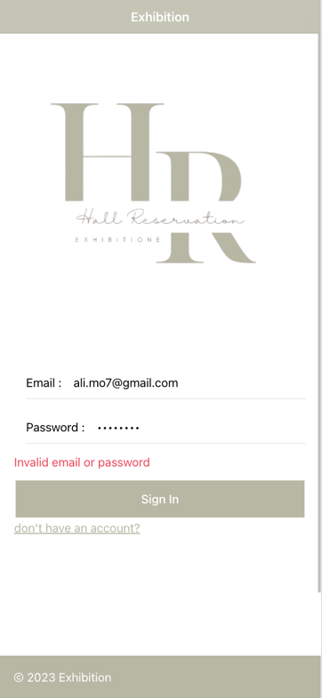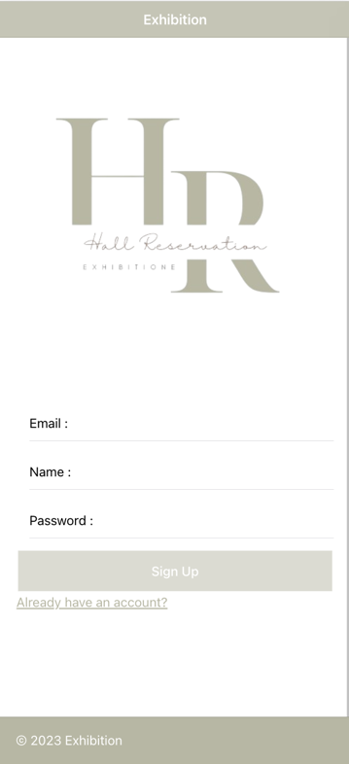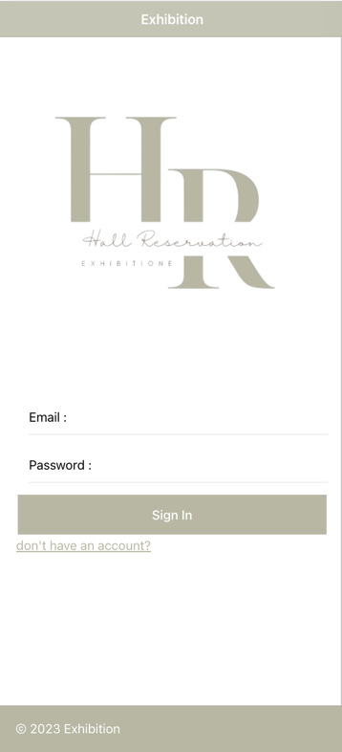In this project, I generated the home page ( sign in / sign up ) and the dashboard page. first, the user must sign in or sign up to have access to all features of the app, users can sign in using their own email and password, and if one of the fields is not valid an appropriate message will be showed to the user, else if he/she does not have an account, they can create a new account with the following fields: email, name, and password. to make sure the user inputs accurate details I used regular expression for validation, so that the button sign up will only be enabled if all fields are valid. Next, in the dashboard page we have buttons to navigate between the pages in addition to a list of hall reservations in the past 30 days, including the hall name and total number of reservations on each hall.

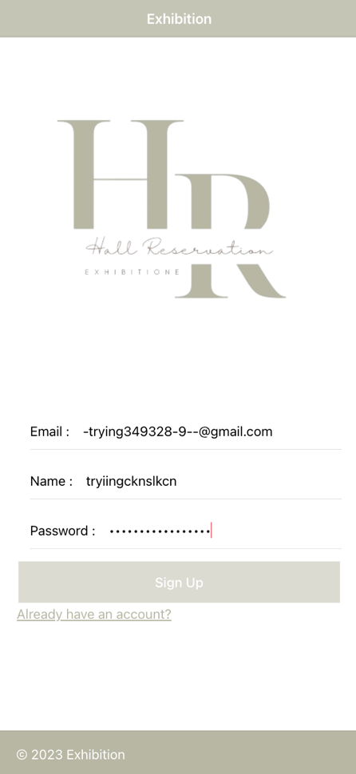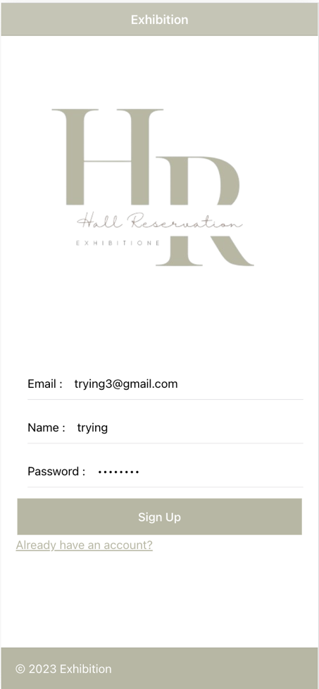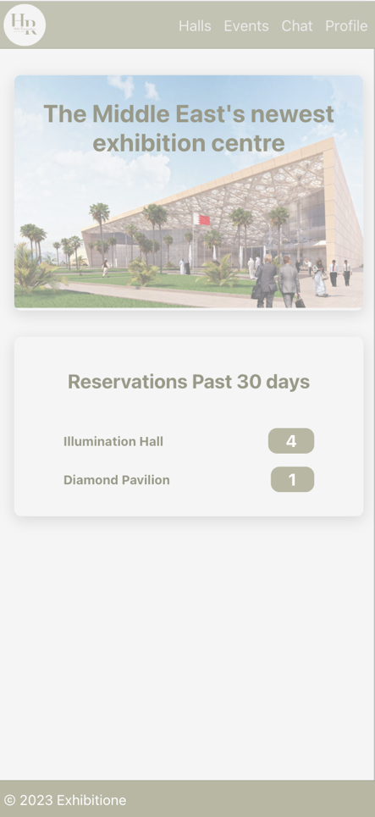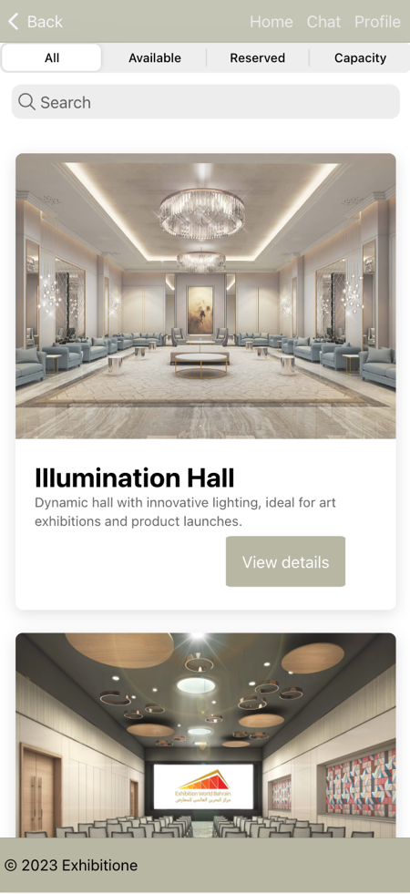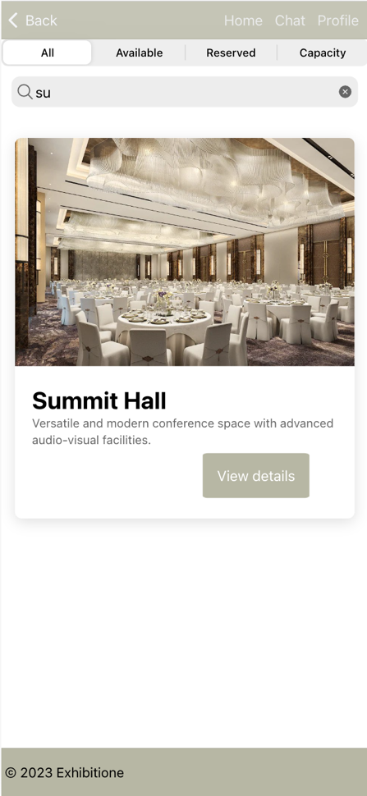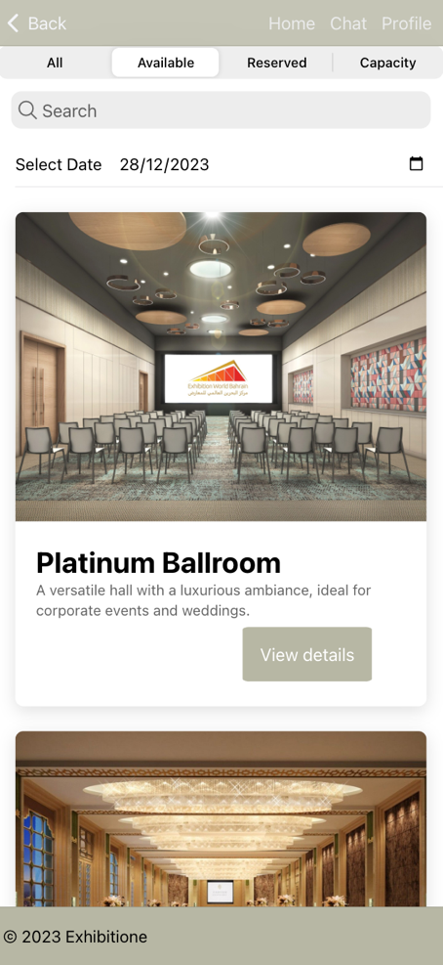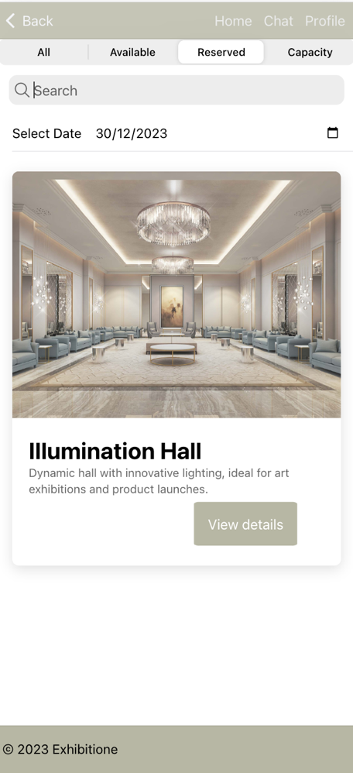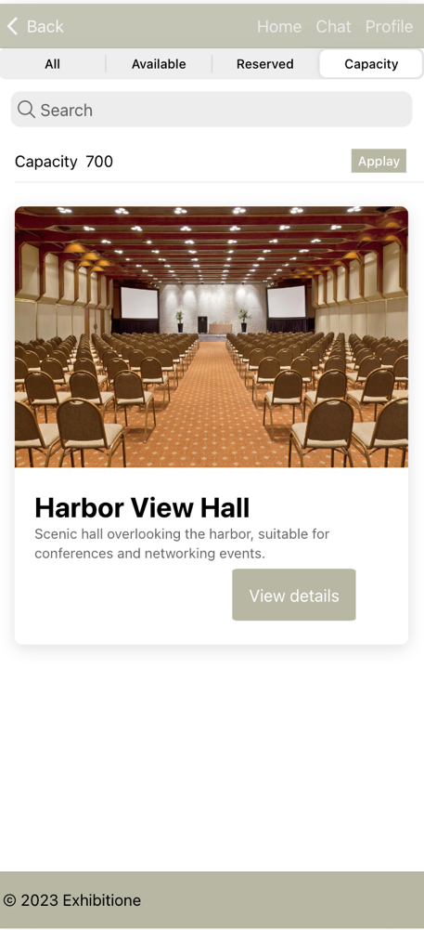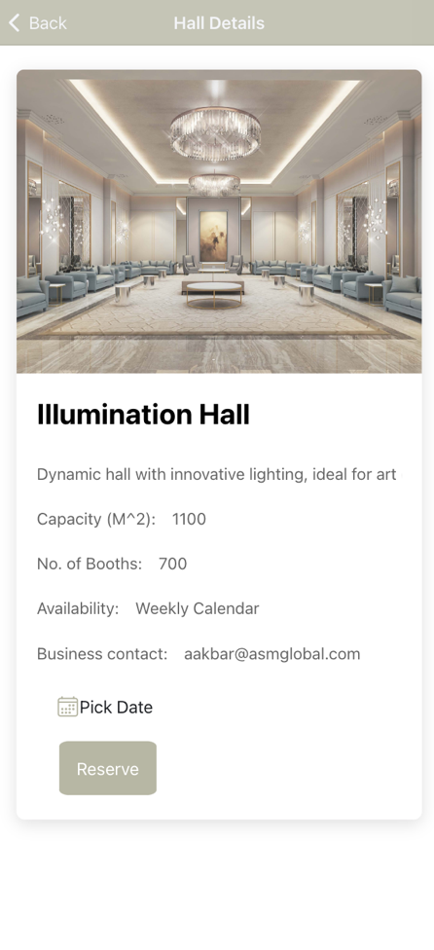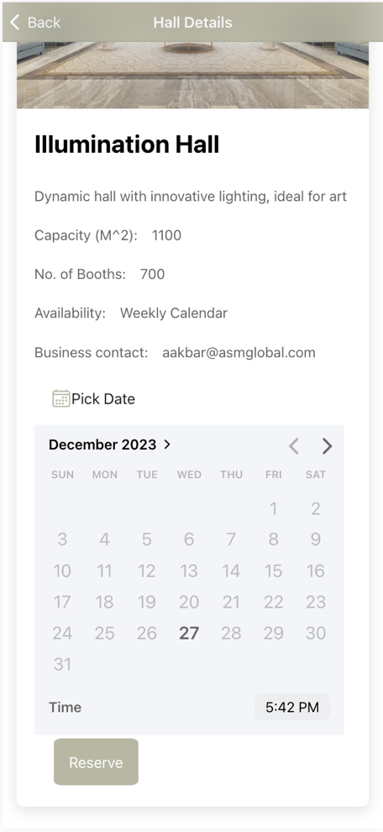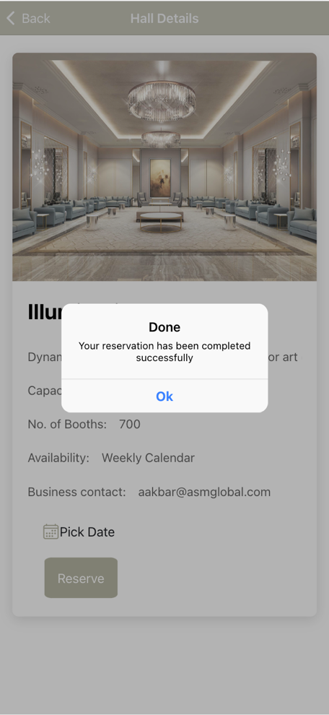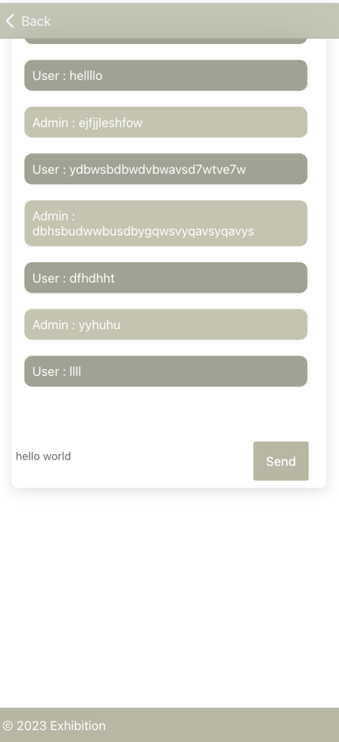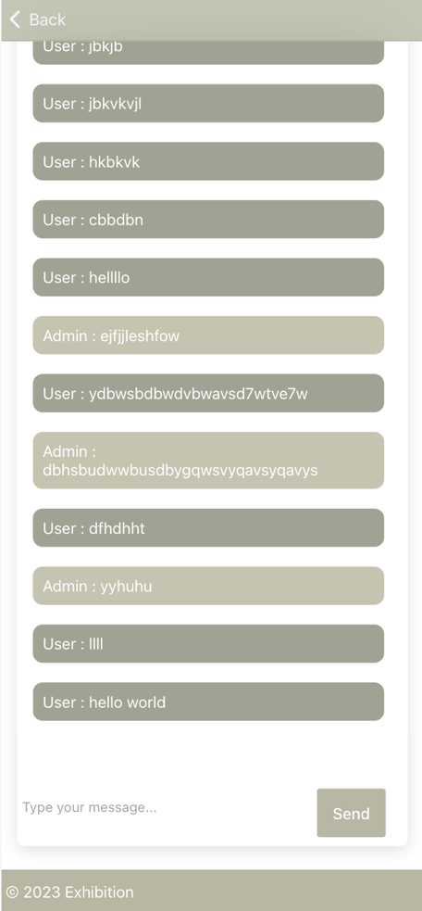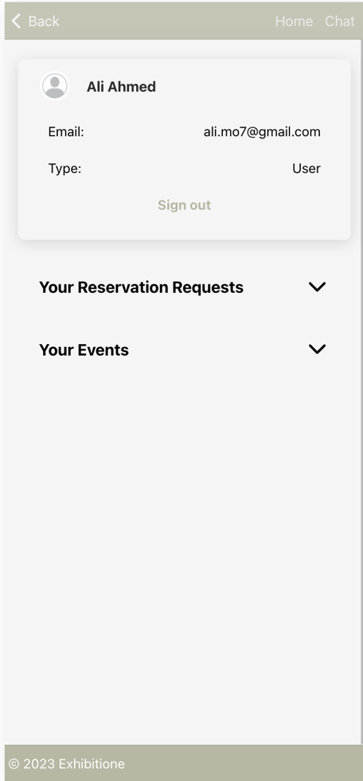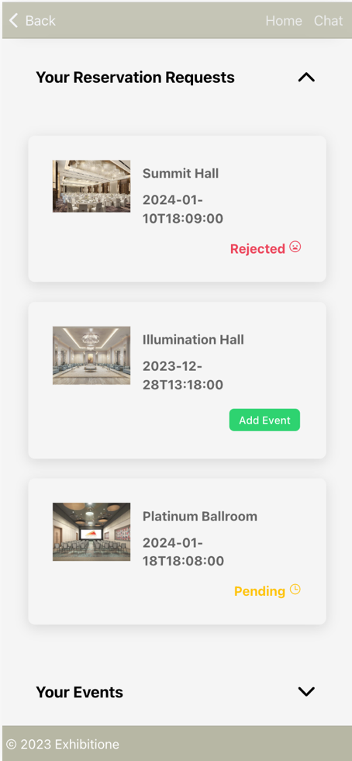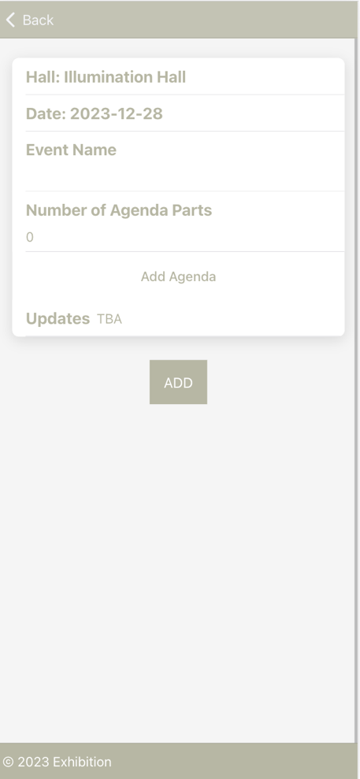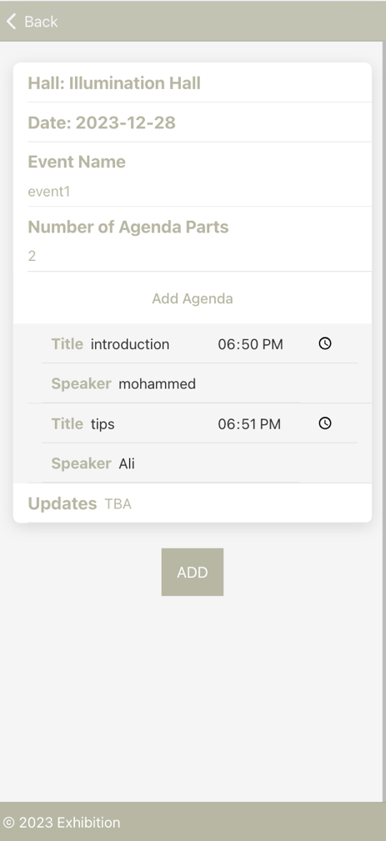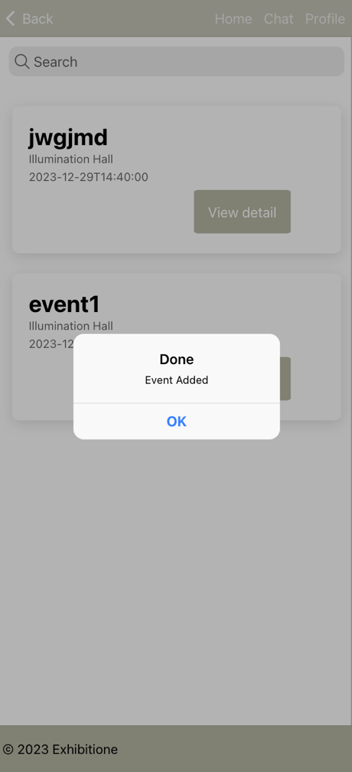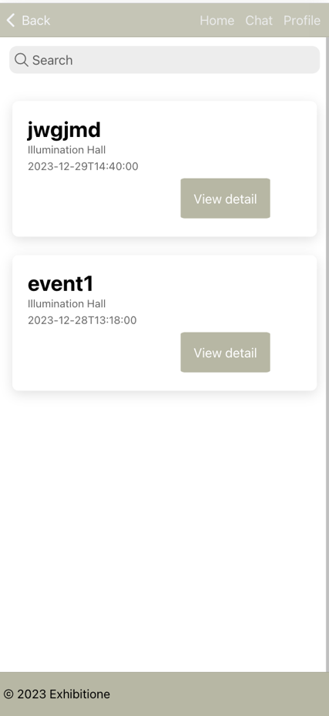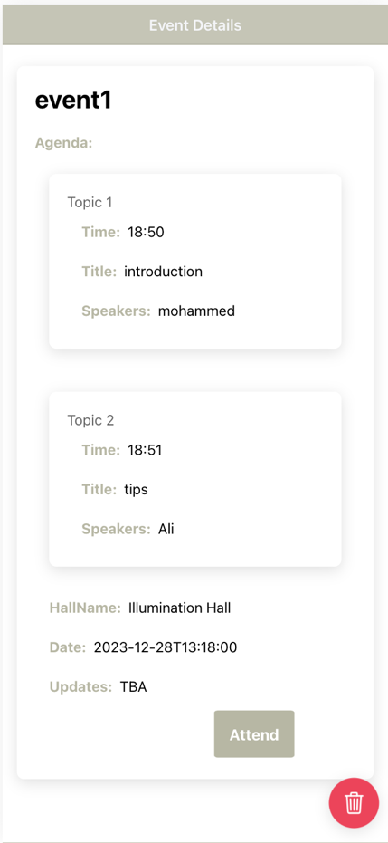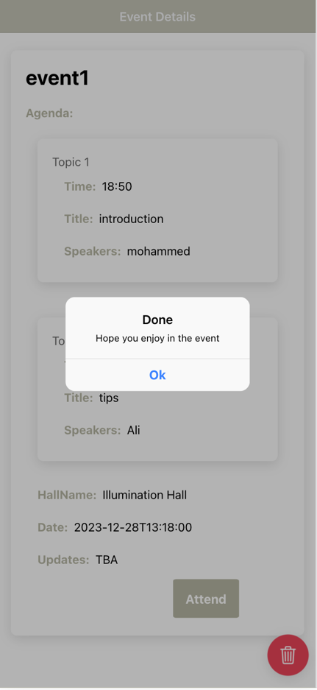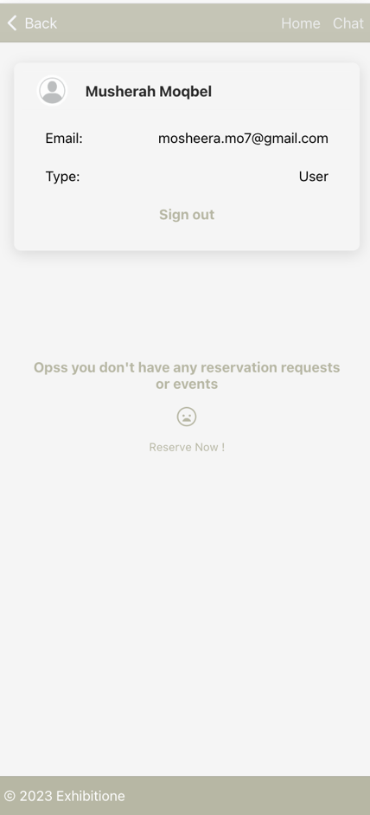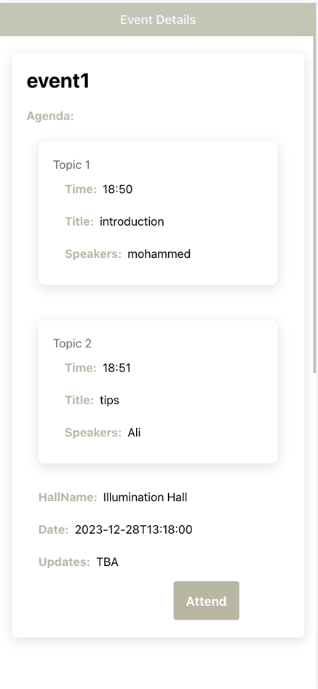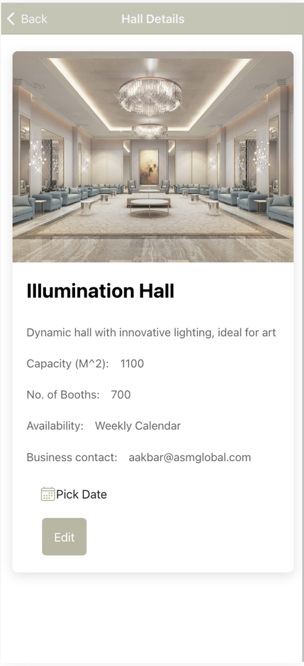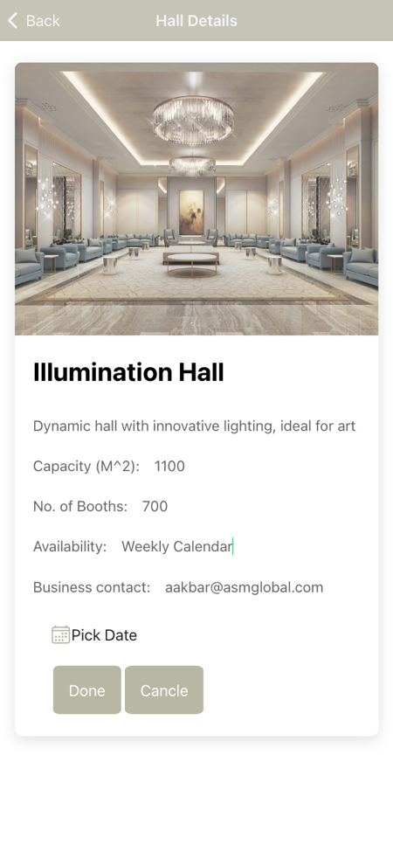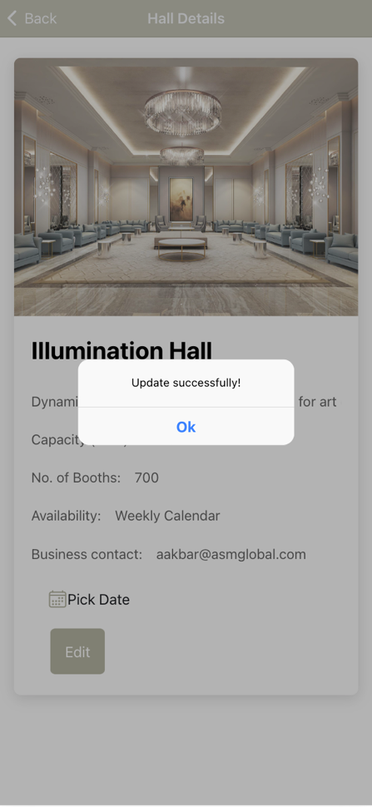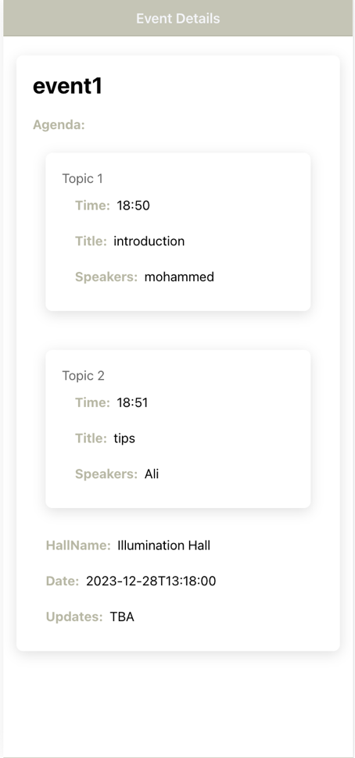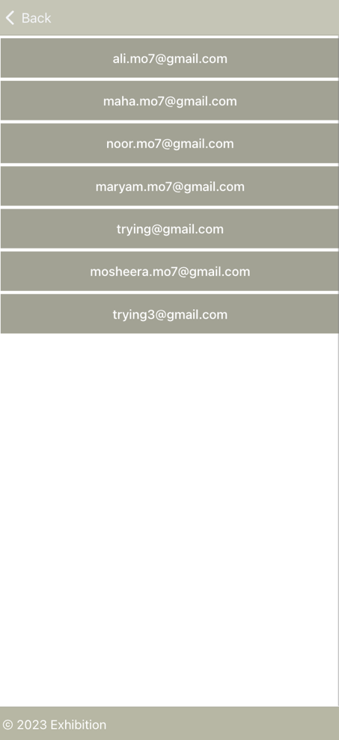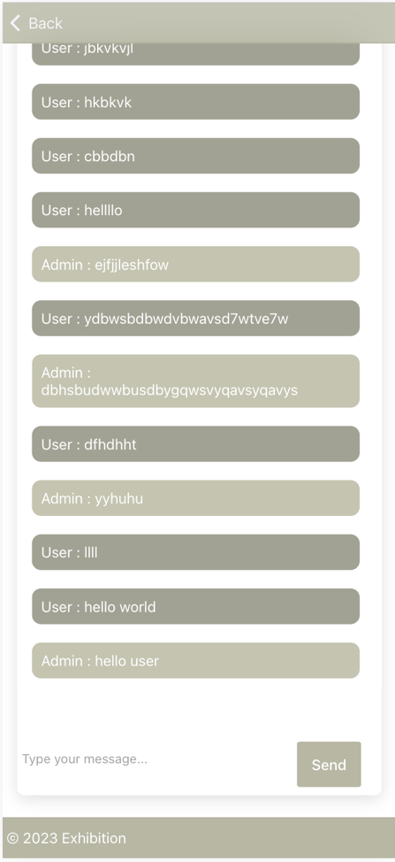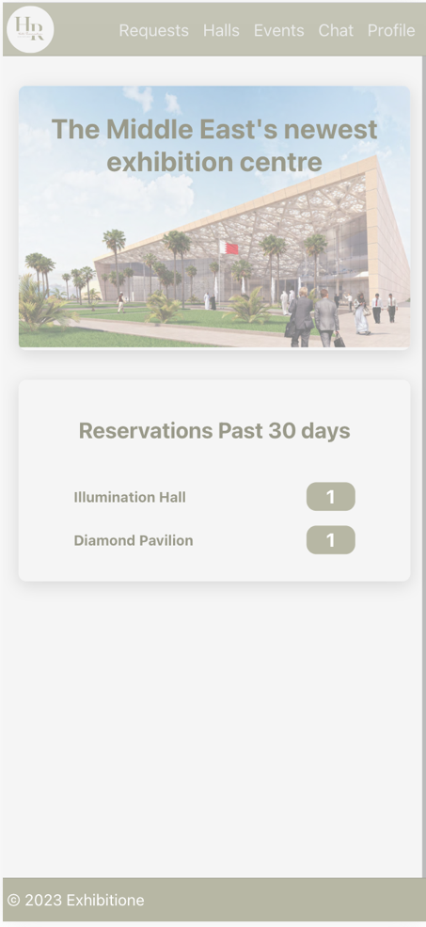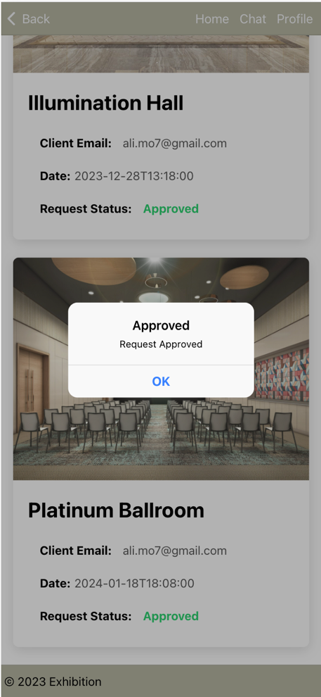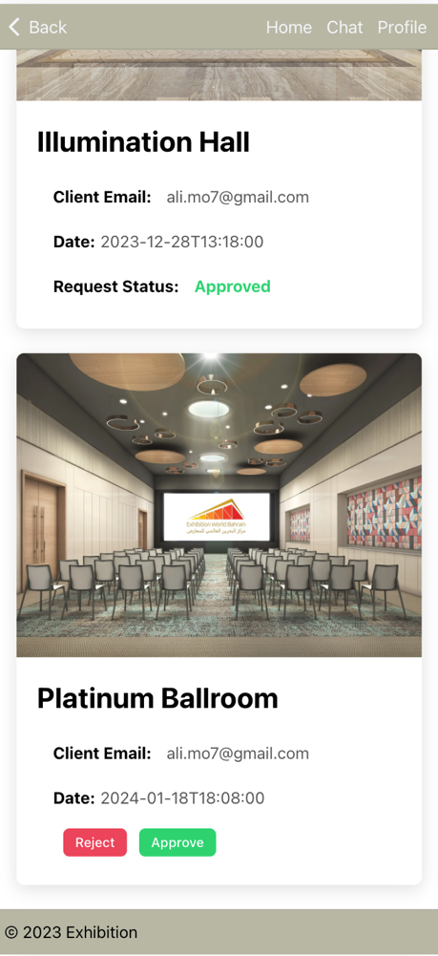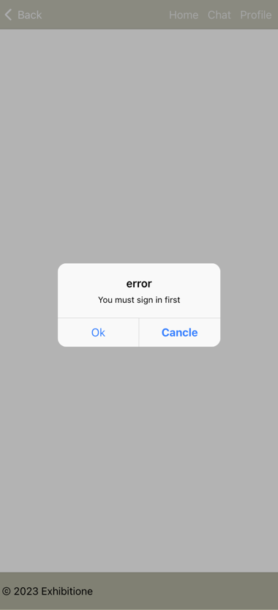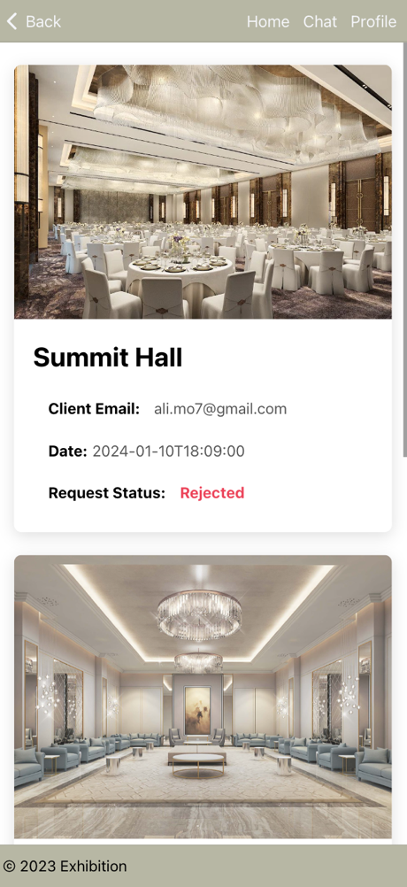

chat

profile

events

if it is admin

if user and not who create the event

if user do not have any reservations

if is admin

if is admin

if is admin

if the user visits the pages without sign in / sign up:

**our database:**



